Big Data & Big Data Analytics

<https://www.geeksforgeeks.org/what-is-big-data-analytics/>

<https://www.geeksforgeeks.org/what-is-big-data/>

Characteristics of Big Data

<https://www.geeksforgeeks.org/5-vs-of-big-data/>

<https://www.coursera.org/articles/5-vs-of-big-data>

Types of Big Data

<https://www.geeksforgeeks.org/types-of-big-data/>

Sources of Big Data

Big Data refers to large, complex datasets generated from a variety of sources at high velocity and volume. These data sources can come from various industries, applications, and devices, contributing to a diverse range of structured, semi-structured, and unstructured data. Understanding the different sources of big data helps businesses harness and analyze these datasets to extract meaningful insights.

Here are some of the **main sources of big data**:

### **1. Social Media Data**

* **Platforms:** Facebook, Twitter, Instagram, LinkedIn, YouTube, TikTok, etc.
* **Data Type:** Unstructured and semi-structured data (text, images, videos, likes, shares, comments, and hashtags).
* **Details:** Social media generates a huge volume of data in the form of user-generated content, user behavior analytics, and social interactions. Businesses often analyze this data to track sentiment, trends, brand reputation, and engagement.

### **2. Machine and Sensor Data**

* **Platforms:** IoT devices, smart sensors, industrial machinery, wearables.
* **Data Type:** Structured data (time series, logs, telemetry data) and semi-structured (JSON/XML data).
* **Details:** IoT sensors embedded in devices like smart meters, cars, weather stations, manufacturing machinery, and even healthcare devices generate continuous streams of data that provide insights into performance, predictive maintenance, and operational efficiency.

### **3. Transactional Data**

* **Platforms:** Point of Sale (POS) systems, online payment gateways, financial transactions, e-commerce systems.
* **Data Type:** Structured data (transaction logs, sales records, invoices, payment histories).
* **Details:** Transactional data captures all business activities and interactions, such as purchases, sales, bookings, and returns. This data is crucial for financial analysis, market trends, and customer behavior tracking.

### **4. Web and Clickstream Data**

* **Platforms:** Websites, e-commerce portals, digital advertising platforms.
* **Data Type:** Semi-structured data (web logs, click paths, page views, user navigation).
* **Details:** Clickstream data is generated by users interacting with websites or applications. It provides insights into user behavior, session duration, page interactions, and navigation patterns, which are essential for optimizing user experience and digital marketing strategies.

### **5. Geospatial Data**

* **Platforms:** GPS devices, satellite imagery, location-based services (Google Maps, ride-sharing apps).
* **Data Type:** Structured and semi-structured data (latitude/longitude coordinates, geotagged photos, map data).
* **Details:** Geospatial data includes geographic location information captured through devices with GPS sensors. It is widely used in logistics, route optimization, urban planning, and location-based advertising.

### **6. Mobile and App Data**

* **Platforms:** Mobile applications, app usage analytics, in-app purchases.
* **Data Type:** Semi-structured and unstructured data (user behavior, session data, app interaction patterns).
* **Details:** Mobile apps generate large volumes of data on user preferences, device information, app usage, and interactions. This data helps developers and businesses personalize services, optimize app performance, and target advertisements.

### **7. Communication Data**

* **Platforms:** Emails, messaging apps (WhatsApp, Slack), VoIP services, customer support platforms.
* **Data Type:** Unstructured data (email content, chat logs, call transcripts).
* **Details:** Data from communication channels helps in sentiment analysis, relationship management, and understanding the tone and context of interactions. This data is particularly useful for improving customer support and internal communication strategies.

### **8. Media and Entertainment Data**

* **Platforms:** Streaming services (Netflix, Spotify, YouTube), news websites, content platforms.
* **Data Type:** Unstructured data (video streams, audio files, images, metadata).
* **Details:** Media companies use data from content consumption, user ratings, reviews, and watch patterns to recommend content, optimize user experiences, and generate targeted advertising.

### **9. Healthcare and Medical Data**

* **Platforms:** Electronic Health Records (EHRs), clinical trials, medical devices, patient monitoring systems.
* **Data Type:** Structured, semi-structured, and unstructured data (medical images, patient records, lab results).
* **Details:** Healthcare data includes patient histories, diagnostic images, treatment outcomes, and real-time monitoring data from wearable devices. This data is used for personalized medicine, patient care optimization, and predictive healthcare analytics.

### **10. Financial and Market Data**

* **Platforms:** Stock exchanges, financial reports, banking systems, cryptocurrency exchanges.
* **Data Type:** Structured data (stock prices, trading volumes, market indices).
* **Details:** Market data from financial markets includes stock prices, currency exchange rates, commodity prices, and investment patterns. Financial institutions use this data for risk analysis, fraud detection, and market trend prediction.

### **11. Government and Public Data**

* **Platforms:** Census data, government reports, open data platforms, public records.
* **Data Type:** Structured and semi-structured data (demographic information, economic data, policy documents).
* **Details:** Government agencies collect vast amounts of public data related to population statistics, economic indicators, and social programs. This data is used for policy-making, research, and public service optimization.

### **12. Audio and Video Data**

* **Platforms:** CCTV surveillance, call centers, video conferencing, voice assistants (Alexa, Siri).
* **Data Type:** Unstructured data (audio recordings, surveillance footage, video streams).
* **Details:** Data from audio and video sources is increasingly being used for security surveillance, facial recognition, and sentiment analysis through voice and image processing technologies.

### **13. Log and Machine Data**

* **Platforms:** Server logs, network monitoring systems, system logs.
* **Data Type:** Structured and semi-structured data (log files, performance metrics, error reports).
* **Details:** Logs generated by servers, applications, and devices provide a rich source of information for debugging, performance monitoring, and security analysis. Companies often use this data for anomaly detection and root cause analysis.

### **14. Scientific Research Data**

* **Platforms:** Research institutions, academic databases, experimental labs.
* **Data Type:** Structured and unstructured data (experiment results, genetic sequences, astronomical data).
* **Details:** Scientific research generates large datasets from experiments, simulations, and observational studies. This data is crucial for advancing knowledge in fields like genomics, physics, and environmental science.

By leveraging these data sources, businesses can generate insights that drive innovation, optimize processes, and improve decision-making. Each source contributes uniquely to the growing pool of big data, making it an essential component of modern analytics strategies.

Big Data Architectures

<https://www.interviewbit.com/blog/big-data-architecture/>

Data Analysis Process

<https://www.geeksforgeeks.org/six-steps-of-data-analysis-process/>

Data Analytics Life Cycle

The data analytics lifecycle is a structured approach designed to address the unique challenges and needs of analyzing large-scale data. This lifecycle guides data scientists, analysts, and business professionals through a series of steps that enable them to systematically work with data, gain insights, and make informed decisions. The lifecycle is iterative, meaning that the steps may be revisited multiple times to refine the analysis and achieve the desired results.

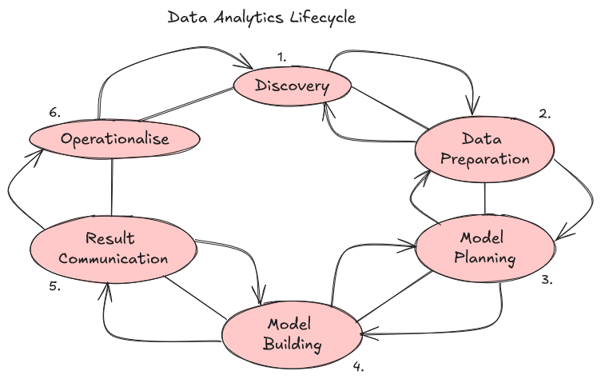

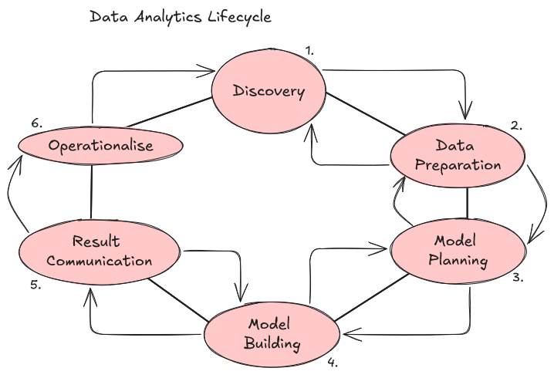

#### **Phase 1: Discovery**

**Objective:** Understand the problem and define the project goals.

* **What It’s About:** In the Discovery phase, the team identifies the business problem or the question they want to answer with data. This phase involves understanding the project’s context, defining the business objectives, and outlining the project’s success criteria.
* **Key Activities:**
  + **Problem Identification:** What are we trying to solve? What decisions do we want to support with data?
  + **Understanding Requirements:** Define what data is needed and identify available data sources.
  + **Initial Hypotheses:** Develop assumptions or hypotheses that can later be validated with data.
* **Outcome:** A clear understanding of what needs to be done, the data requirements, and an initial hypothesis to test.

#### **Phase 2: Data Preparation**

**Objective:** Prepare data for analysis.

* **What It’s About:** This phase is all about collecting, cleaning, and organizing data. The team brings in raw data from different sources, and then performs tasks like data cleaning (removing errors, duplicates, and irrelevant information) and transformation (converting data into a usable format). The goal is to make the data consistent, reliable, and ready for analysis.
* **Key Activities:**
  + **Data Cleaning:** Handle missing values, correct inconsistencies, and remove outliers.
  + **Data Transformation:** Convert data into the right format (e.g., changing text into numbers).
  + **Data Integration:** Combine data from multiple sources.
* **Outcome:** A cleaned, well-structured dataset that’s ready for further analysis.

#### **Phase 3: Model Planning**

**Objective:** Choose the right analysis methods and techniques.

* **What It’s About:** In this phase, the team decides on the strategy and techniques to analyze the data. They might explore the relationships between different variables, create data subsets for training and testing, and choose algorithms that match the business objectives.
* **Key Activities:**
  + **Exploratory Data Analysis (EDA):** Use graphs and visualizations to identify trends, correlations, and patterns.
  + **Selecting Algorithms:** Choose the best-suited algorithms and models for the data.
  + **Data Partitioning:** Split the data into training, testing, and validation sets.
* **Outcome:** A detailed plan for building and evaluating models using the selected methods and data subsets.

#### **Phase 4: Model Building**

**Objective:** Create and test predictive models.

* **What It’s About:** Here, the team builds and tests different models based on the planned approach. They feed the training data into the models, tune parameters, and evaluate the models’ accuracy using the testing data.
* **Key Activities:**
  + **Model Building:** Develop multiple models using different techniques (e.g., regression, classification, clustering).
  + **Model Validation:** Test the models using the validation data to ensure they work as expected.
  + **Refinement:** Adjust models to improve their performance.
* **Outcome:** A validated model that’s ready for deployment and provides accurate predictions.

#### **Phase 5: Results Communication**

**Objective:** Share insights and findings with stakeholders.

* **What It’s About:** Once the models are built and validated, the results need to be communicated in a clear and impactful way. The team presents their findings, highlights key insights, and explains the business value in non-technical language to the stakeholders.
* **Key Activities:**
  + **Creating Reports and Visualizations:** Use charts, graphs, and presentations to make the results easy to understand.
  + **Communicating Results:** Share insights, predictions, and actionable recommendations.
  + **Quantifying Business Impact:** Demonstrate how the findings can solve business problems or support decision-making.
* **Outcome:** A clear understanding of the analysis results and their implications for the business.

#### **Phase 6: Operationalization**

**Objective:** Deploy the models and make them accessible.

* **What It’s About:** In this final phase, the validated models are deployed in a production environment where they can be used for decision-making, automating processes, or creating new applications. The deployment is often done on a small scale (pilot project) first, to monitor performance and identify any issues.
* **Key Activities:**
  + **Deploying Models:** Implement models in a live environment.
  + **Monitoring and Maintenance:** Continuously monitor the model’s performance and make updates as needed.
  + **Creating Documentation and Reports:** Share documentation, code, and deployment details with relevant teams.
* **Outcome:** The model is operational, providing real-time insights and supporting business decisions.

### Key Takeaways

The Data Analytics Lifecycle is not a linear process but an iterative one. You might revisit earlier phases based on new findings or business changes. Additionally, each phase may require specific tools and software depending on the project’s complexity. While tools like **Python, R, SQL, and Hadoop** are commonly used, the choice depends on the project’s requirements and available resources.

By understanding this lifecycle, businesses can more effectively plan, execute, and benefit from data analytics projects, ensuring that the results are aligned with strategic goals.

### **Big Data Preprocessing**

Big data preprocessing is a crucial step in the data analytics process. Before conducting any meaningful analysis or applying machine learning models, raw data must be cleaned, structured, and transformed. Big data is often unorganized, incomplete, and noisy, which can lead to biased or inaccurate results if not handled properly. Preprocessing prepares the data for analysis by making it consistent, relevant, and suitable for the intended applications.

### **Key Stages in Big Data Preprocessing**

1. **Data Collection**
2. **Data Cleaning**
3. **Data Integration**
4. **Data Transformation**
5. **Data Reduction**
6. **Data Validation**

### **1. Data Collection**

Data collection involves gathering raw data from various sources, such as IoT devices, databases, web logs, and social media platforms. The data collected is usually heterogeneous, coming in different formats (structured, semi-structured, or unstructured).

* **Objective:** To consolidate data from multiple sources into a central repository.
* **Challenges:** Handling large volumes of data in real-time, dealing with missing values, noise, and varying formats.

**Tools:**

* **Apache Kafka** - For real-time data streaming.
* **Flume** - For aggregating and transferring logs.
* **Apache NiFi** - For automated data flow and collection.

### **2. Data Cleaning**

Data cleaning involves detecting and correcting errors, handling missing values, and dealing with noise in the data. Inconsistent data, duplicates, and irrelevant information are removed or corrected in this stage. Since big data often contains a lot of noise and errors, cleaning is an essential step.

* **Objective:** To improve the quality of data by removing anomalies and inconsistencies.
* **Tasks:**
  + Handling missing values (e.g., filling in, dropping).
  + Removing duplicate entries.
  + Handling outliers and noisy data.
  + Correcting inconsistencies (e.g., mismatched values, data formats).

**Tools:**

* **OpenRefine** - For cleaning and transforming large datasets.
* **Pandas (Python)** - For data manipulation and cleaning.
* **Apache Spark** - For large-scale data cleaning with distributed processing.

### **3. Data Integration**

Data integration involves combining data from multiple heterogeneous sources into a coherent data store, such as a data lake or warehouse. This stage is necessary when data comes from multiple systems or formats that need to be unified.

* **Objective:** To create a unified view of data from different sources.
* **Tasks:**
  + Merging datasets from different sources.
  + Matching and linking records from different data silos.
  + Dealing with schema mismatches.

**Tools:**

* **Apache Hive** - For querying and integrating structured data.
* **Apache Pig** - For integrating data at a high level.
* **Talend**, **Informatica** - For ETL (Extract, Transform, Load) processes.

### **4. Data Transformation**

Data transformation involves converting data into a suitable format for analysis. This may include scaling, normalization, encoding categorical variables, and deriving new features. With big data, transformations must be optimized to handle large volumes efficiently.

* **Objective:** To change the format, structure, or values of the data to ensure it is suitable for analysis.
* **Tasks:**
  + Aggregating data (e.g., summing, averaging).
  + Normalization (scaling numeric values).
  + One-hot encoding for categorical variables.
  + Feature engineering to create new attributes from existing ones.

**Tools:**

* **Apache Spark (MLlib)** - For scalable data transformations.
* **Python (Scikit-learn)** - For data transformation and feature engineering.
* **DataFrame libraries (e.g., Pandas)** - For reshaping and transforming data.

### **5. Data Reduction**

Data reduction techniques are used to minimize the volume of data while maintaining its integrity. Since big data often involves petabytes of information, reducing data size without losing critical information is crucial for faster processing and storage efficiency.

* **Objective:** To reduce the volume of data while preserving its meaning and structure.
* **Tasks:**
  + Dimensionality reduction (e.g., Principal Component Analysis).
  + Sampling a subset of data.
  + Aggregating data at different levels (e.g., monthly instead of daily).
  + Removing irrelevant or redundant features.

**Tools:**

* **Apache Mahout** - For implementing scalable machine learning algorithms for data reduction.
* **Python (PCA with Scikit-learn)** - For dimensionality reduction.
* **Hadoop MapReduce** - For aggregating data in a distributed manner.

### **6. Data Validation**

Data validation ensures that the processed data meets the desired quality and format requirements. This step involves running checks on the cleaned, integrated, and transformed data to verify its consistency, accuracy, and completeness.

* **Objective:** To validate the data quality and format before further analysis.
* **Tasks:**
  + Schema validation to check data types and formats.
  + Range and boundary checks for numerical attributes.
  + Consistency checks across datasets.

**Tools:**

* **Great Expectations** - For validating and documenting data expectations.
* **Deequ (by AWS)** - For data quality checks on large datasets.
* **Pandas (Python)** - For custom data validation scripts.

### **Common Big Data Preprocessing Tools and Frameworks**

|  |  |
| --- | --- |
| **Tool/Framework** | **Description** |
| **Apache Spark** | A unified analytics engine for large-scale data processing with built-in modules for SQL, machine learning, and stream processing. |
| **Apache Hadoop** | A framework that allows the distributed processing of large data sets across clusters of computers. |
| **Python Libraries** | Libraries like Pandas, Numpy, and Scikit-learn for data manipulation, cleaning, and transformation. |
| **OpenRefine** | A powerful tool for working with messy data: cleaning, transforming, and exploring large datasets. |
| **Talend** | An ETL tool for data integration and preprocessing across various data sources. |
| **KNIME** | An open-source platform for data analytics, reporting, and integration. |
| **Informatica** | A widely used tool for data integration and ETL operations. |
| **AWS Glue** | A serverless data integration service for cleaning, transforming, and loading data. |

### **Challenges in Big Data Preprocessing**

1. **Scalability:** Handling extremely large volumes of data can be challenging and may require distributed computing frameworks.
2. **Data Quality Issues:** Dealing with missing values, noisy data, and inconsistent formats at scale.
3. **Heterogeneity:** Integrating data from various sources, including structured, semi-structured, and unstructured formats.
4. **Real-Time Processing:** Handling streaming data and ensuring that transformations and validations are applied in real-time.

By effectively preprocessing big data, organizations can significantly enhance the quality and reliability of their analysis, ensuring that insights derived are accurate and actionable.

Market and Business Drivers for Big Data Analytics in pdf

Business Problems Suited to Big Data Analytics  
  
From PDF